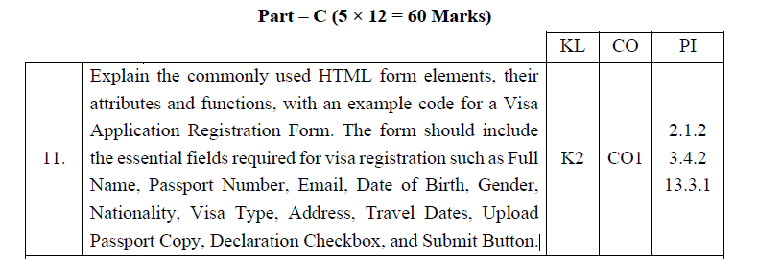

Explain the commonly used HTML form elements, their attributes and functions, with an example code for a Visa Application Registration Form. The form should include the essential fields required for visa registration such as Full Name, Passport Number, Email, Date of Birth, Gender, Nationality, Visa Type, Address, Travel Dates, Upload Passport Copy, Declaration Checkbox, and Submit Button.

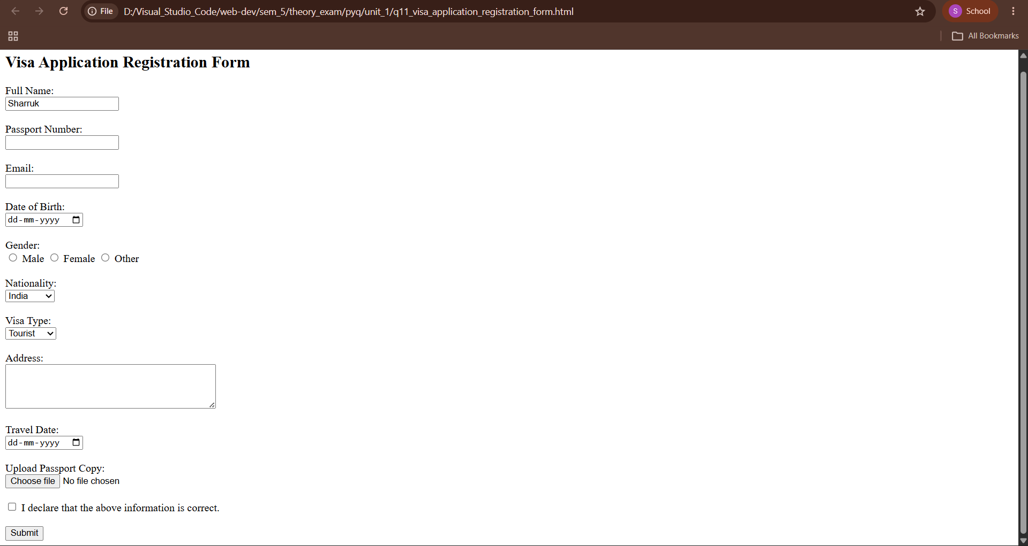

<!--
Question No: 11
Part C - 12 Marks

Explain the commonly used HTML form elements, their attributes and functions,
with an example code for a Visa Application Registration Form.

The form should include:

- Full Name
- Passport Number
- Email
- Date of Birth
- Gender
- Nationality
- Visa Type
- Address
- Travel Dates
- Upload Passport Copy
- Declaration Checkbox
- Submit Button
-->

<!DOCTYPE html>
<html>
<head>
<title>Visa Registration Form</title>
</head>

<body>

<h2>Visa Application Registration Form</h2>

<form>

<label>Full Name:</label><br>
<input type="text" required><br><br>

<label>Passport Number:</label><br>
<input type="text" required><br><br>

<label>Email:</label><br>
<input type="email" required><br><br>

<label>Date of Birth:</label><br>
<input type="date"><br><br>

<label>Gender:</label><br>

<input type="radio" name="gender"> Male

<input type="radio" name="gender"> Female

<input type="radio" name="gender"> Other

<br><br>

<label>Nationality:</label><br>

<select>

<option>India</option>

<option>USA</option>

<option>Canada</option>

<option>Australia</option>

</select>

<br><br>

<label>Visa Type:</label><br>

<select>

<option>Tourist</option>

<option>Business</option>

<option>Student</option>

<option>Work</option>

</select>

<br><br>

<label>Address:</label><br>

<textarea rows="4" cols="40"></textarea>

<br><br>

<label>Travel Date:</label><br>

<input type="date">

<br><br>

<label>Upload Passport Copy:</label><br>

<input type="file">

<br><br>

<input type="checkbox">

I declare that the above information is correct.

<br><br>

<input type="submit" value="Submit">

</form>

</body>
</html>

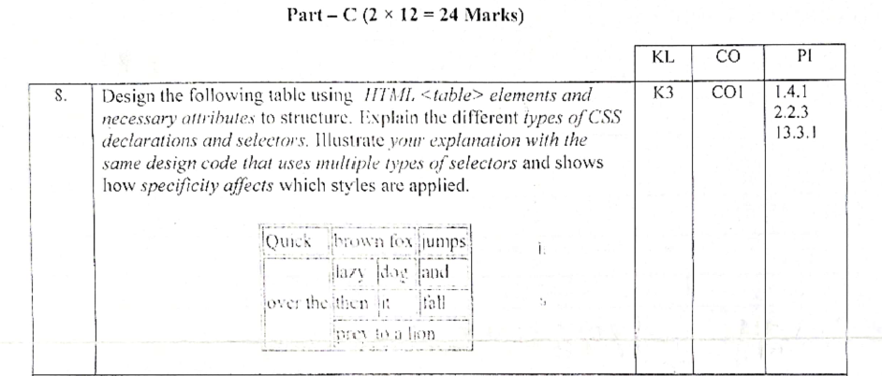
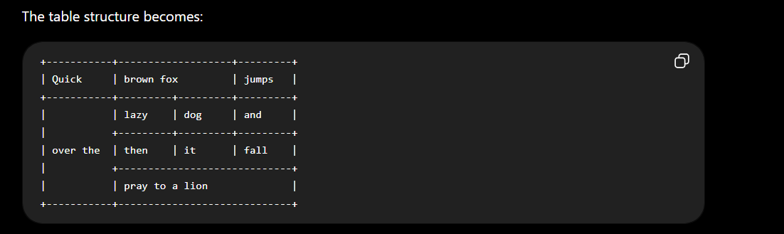

Q8. Design the following table using HTML <table> elements and necessary attributes to structure. Explain the different types of CSS declarations and selectors. Illustrate your explanation with the same design code that uses multiple types of selectors and shows how specificity affects which styles are applied.

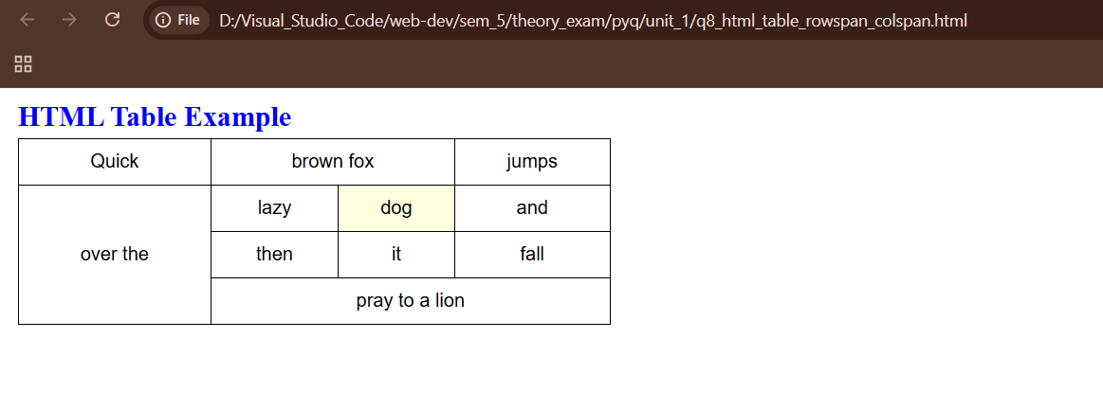

<!--
Question No: 12
Part C - 12 Marks

Create the following HTML table using rowspan and colspan.

+-----------+-------------------+---------+
| Quick | brown fox | jumps |
+-----------+---------+---------+---------+
| | lazy | dog | and |
| +---------+---------+---------+
| over the | then | it | fall |
| +-----------------------------+
| | pray to a lion |
+-----------+-----------------------------+

Use appropriate HTML table tags.
Include CSS selectors wherever required.
-->
<!DOCTYPE html>
<html>
<head>

<title>Table Design</title>

<style>

table{
border-collapse:collapse;
width:500px;
}

td{
border:1px solid black;
padding:10px;
text-align:center;
}

/* Element Selector */
td{
font-family:Arial;
}

/* Class Selector */
.highlight{
background-color:lightyellow;
}

/* ID Selector */
#title{
color:blue;
}

/* Universal Selector */
*{
margin:5px;
}

</style>

</head>

<body>

<h2 id="title">HTML Table Example</h2>

<table>

<tr>
<td>Quick</td>
<td colspan="2">brown fox</td>
<td>jumps</td>
</tr>

<tr>
<td rowspan="3">over the</td>
<td>lazy</td>
<td class="highlight">dog</td>
<td>and</td>
</tr>

<tr>
<td>then</td>
<td>it</td>
<td>fall</td>
</tr>

<tr>
<td colspan="3">pray to a lion</td>
</tr>

</table>

</body>
</html>

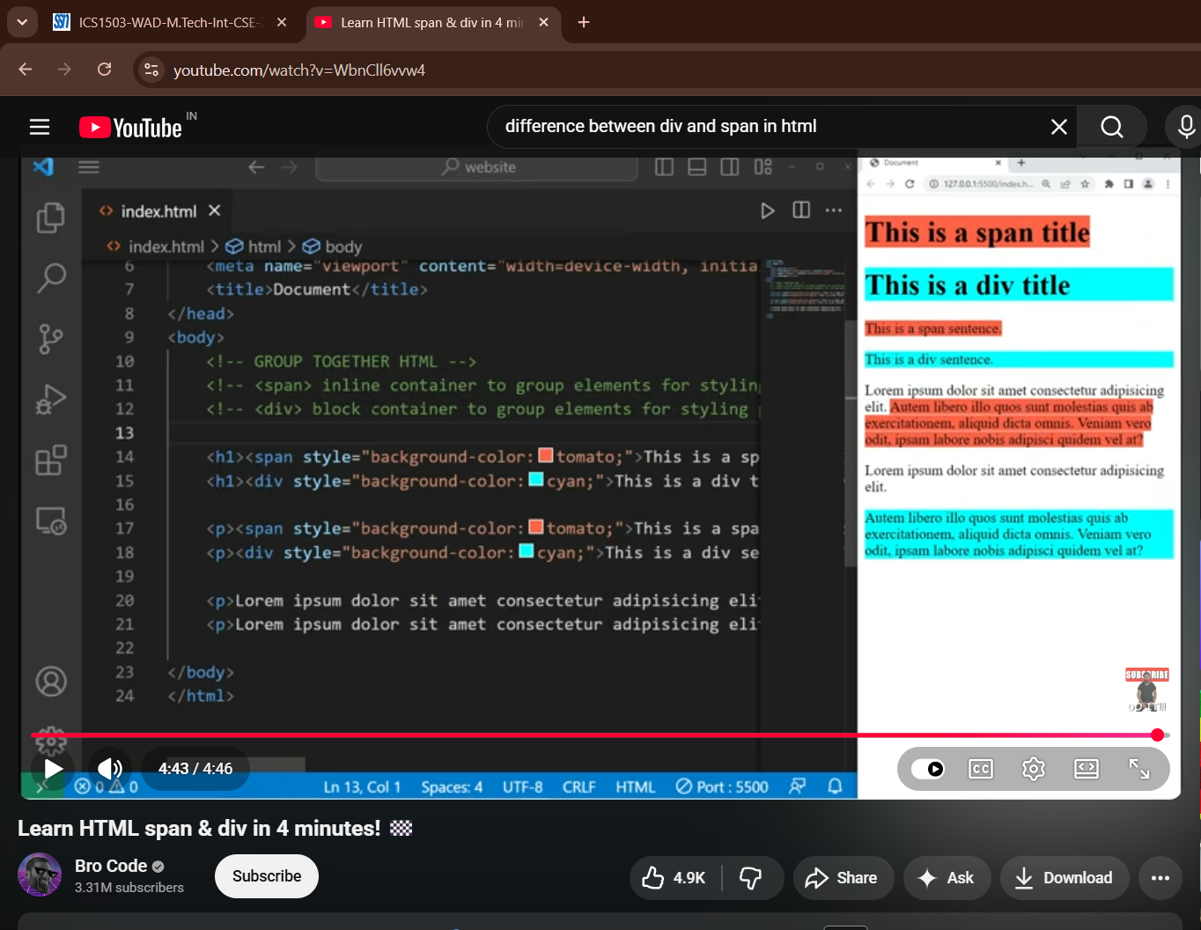
Yes. Since this is a 2-mark question, don't write a long explanation or HTML program. The examiner expects a definition + 4–5 differences.

Q2. Explain the differences between the <div> and <span> elements in HTML. (2 Marks)
<div> and <span> are generic container elements used to group HTML content for applying CSS styles or JavaScript.
<div> | <span>
Block-level element | Inline element
Starts on a new line | Does not start on a new line
Occupies the full available width | Occupies only the required width
Used to group large sections of content | Used to style or group small portions of text
Can contain block-level and inline elements | Can contain text and other inline elements
Example:
<div>This is a DIV element</div>

<p>This is a <span>SPAN</span> element.</p>

📝 Short Exam Version (if you're running out of time)
<div> | <span>
Block-level | Inline
New line | Same line
Full width | Required width only
Large content | Small text/content
This is sufficient for a 2-mark university exam.

1. | Explain difference between cell padding and cell spacing. | K2 | CO1 | 1.4.1

Q1. Explain the difference between Cell Padding and Cell Spacing. (2 Marks)
Cell Padding | Cell Spacing
Space between the cell content and its border. | Space between adjacent table cells.
Increases the space inside a cell. | Increases the space between cells.
Applied using the cellpadding attribute (or CSS padding). | Applied using the cellspacing attribute (or CSS border-spacing).
Affects the size of individual cells. | Affects the gap between cells in the table.

Example
<table border="1" cellpadding="10" cellspacing="5">
<tr>
<td>HTML</td>
<td>CSS</td>
</tr>
</table>
- cellpadding="10" → Adds 10 px space inside each cell.
- cellspacing="5" → Adds 5 px space between cells.

